



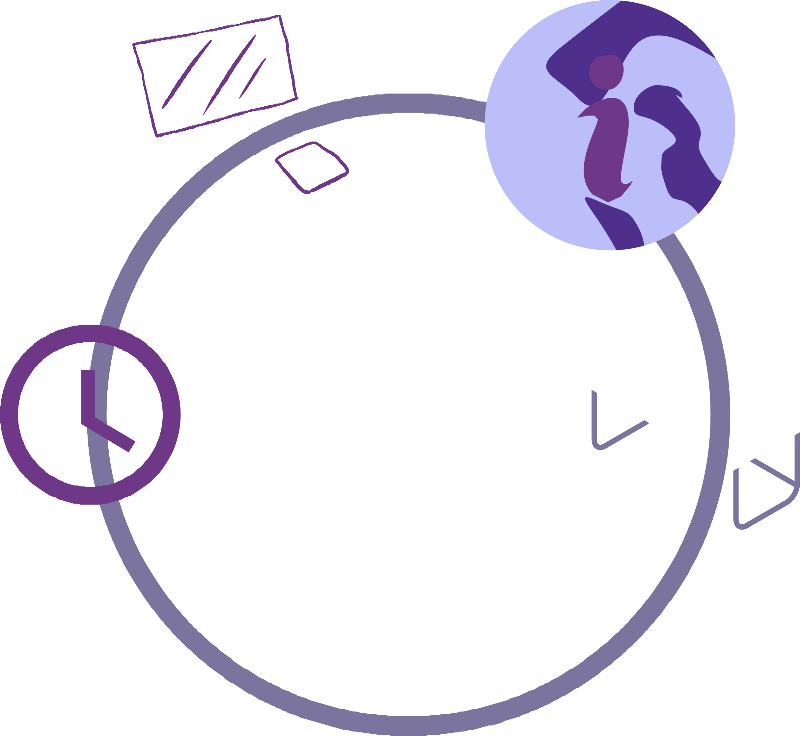

Health Passport

Health Passport.
Your Preferred Name:

Role:

Department:

This is your health passport, which you own and take with you as you move through roles within the NHS.
This is a confidential document only to be shared with consent of the person named above.

The passport is a place where you can share any information you would like to about a disability, long term health condition, mental health issue or learning disability/difficulty.

You can use this passport to tell a new or existing line manager about your health and anything you have in place in the workplace which enables you to carry out your role.

These changes may be those you need all the time, or changes you have in place to accommodate fluctuations in your health.

This passport contains four sections for you to provide details about yourself and your access requirements in the workplace:

- About me and what to know.
- Things that help me to do my role.
- Technology & equipment.
- Communicating at work.
- How to identify when I need additional support.
- How can you tell I need additional support
- What has worked in the past?
- Additional information.
- Keep your passport up to date.

You can make changes to the information within the passport when you need to. These should be shared with your line manager and then recorded on the back page of the passport.

About me and what to know.
What is your condition/disability and how would you describe it? We want to know about YOU. Physical/Emotional/Social/Behavioural

Physical:

Emotional:

Social:

Behavioural:

Things that help me to do my role.

My skills: This is an opportunity to list your skills and abilities:

Time:
What times of the day work best for you?
For example, you might work better in the morning or prefer a later start time. You may also like to have a set lunch break time.

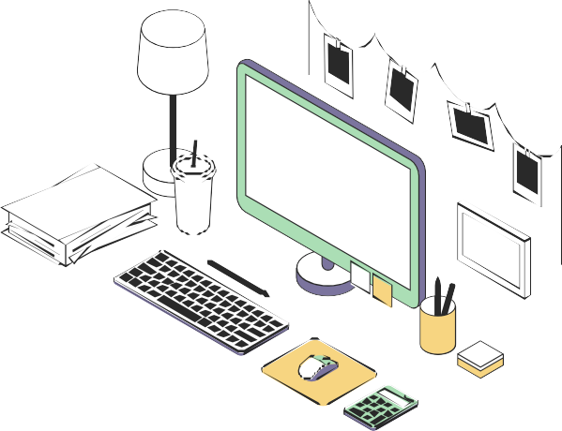
Space:
What sort of space do you like working in and are there any access requirements to support you?


Technology and
equipment.
What technology and equipment helps
you at work?

Communicating at work.
How do you like to receive communication and tasks at work?
You can use this passport to record any changes in your needs, preferences, or working environment – whatever feels helpful to you.

For example, you may like to be emailed your work tasks to help you remember or priorities.

How to identify when I need additional support.
What challenges may impact my capabilities and potential? For example, loud noises, bright lights, sudden changes in work schedule, changes in medication and hospital appointments.

How can you tell I need additional support?
For example:
Signs: Tiredness, Quiet, Timing issues.
How to Help? Space, Smaller tasks, Time to talk.

What has worked in the past?
What has worked for you previously that offered the best working environment for you?

Additional Information.
This space is yours. You can use it to share anything else you’d like others to understand about you, in your own words. If you’ve had conversations with your manager or team and want to note anything helpful here, you’re welcome to – but there’s no pressure. This passport is for you, to help you be understood and support in a way that feels right.

Keep your passport up to date.
You can record any changes to your condition or to your working environment in the passport.

Please add the date and sign it so both you and your manager can check that you have the latest version.
